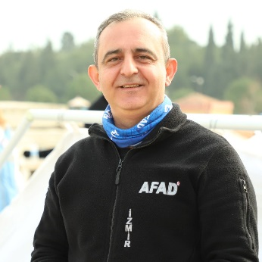
About Hakan Esmergul
Ministry of Interior Disaster and Emergency Management Presidency has been providing Search and Rescue Trainer, Humanitarian and Psycho-social Support Trainer, Disaster Awareness Trainer, Emergency Team Training and Disaster Volunteer Trainer since 2001.
He is a graduate of Anadolu University, Department of Emergency and Disaster Management (2020), Department of Public Administration (2007). He has a Community Disaster Volunteer Trainer Certificate (2006) from Boğaziçi University.
He worked in Kahramanmaraş Tent City, which was established in 2012 for refugees who came to our country due to the civil war in Syria.
Within the scope of the IPA FLOODS project supported by the European Union and European Civil Protection; He took part in the "Operational Training of National Teams High Capacity Pumping and Flood Conservation for Members of the Multinational Civil Protection Module" held in Germany and “Flood Prevention, Preparedness and Response in the Western Balkans and Turkey" programs held in Croatia.
Hakan served as AFAD coordinator in humanitarian activities in Syria's Elbab, Kabbasin and Bzaa regions in 2020. During this period, he has cooperated with the humanitarian actors (associations, NGOs, producers' federation, municipal council members and state actors) working in the region.
He received his first Sphere training online while serving in Syria and has since applied The Humanitarian Charter and Minimum Standards to his work plan.
ToT in online teaching methods for DPPI trainee trainers, Nov-Dec 2021
Sphere Standards, Training of Trainers (TOT) with DPPI-SEE, Albania, 13-17 June 2022

