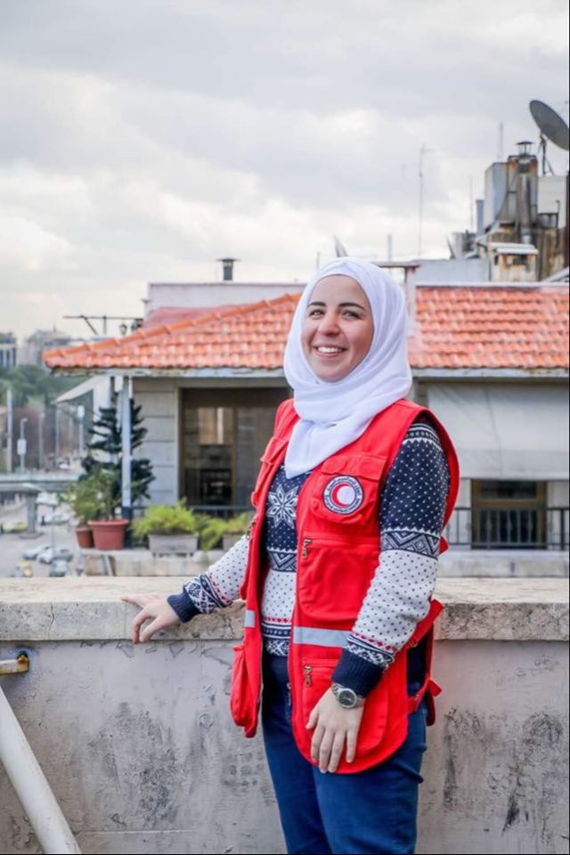 |  |  |  | Shaza  Bashar Al-Massarani -Resume

Experience
- M&E officer - Syrian Arab Red Crescent-Damascus-Head Quarter- since 2020 till now,
- Assist in the revision of the project log frame matrix, particularly in the areas of performance indicators and their measurement.
- Assist in the development and/or finalization of the project Work Plan and keep it updated in accordance with project activities and timeframes as relevant.
- Develop the overall framework, for project M&E, for example, mid-term project review, impact assessment, final evaluation, and develop project Performance Monitoring Plan with relevant data collection systems.
- Review the quality of existing data in the project subject areas, the methods of collecting it, and the degree to which it will provide good baseline statistics for impact evaluation.
- Develop baseline data for each project component and for all project indicators
- Collect data on a regular basis to measure achievement against the performance indicators.
- Check data quality with partners.
- Maintain and administer the M&E database; analyze and aggregate findings.
- Support project progress reporting, project mid-term review, and final evaluation.

- Hygiene promotion coordinator - Syrian Arab Red Crescent-Homs branch – since 2017 till 2020
- Document and share lessons learned and success stories in relation to hygiene to inform future programming.
- Ensure proper implementation of hygiene and sanitation component of WASH projects with-in allocated budget and timeline meeting international standards.
- Ensure integration of Water, sanitation and hygiene promotion components of projects.
- Prepare monthly field reports covering all hygiene and sanitation components and submit to Senior EH Officer.
- Undertake need assessments and contribute in the preparation of new proposals.
- Visit the camp regularly and provide on-site mentoring to hygiene and sanitation team in the camp.
- Ensure that procurements are timely initiated, monitored and prioritized by the logistics team;
- Monitor and ensure spending against plan, and analyze monthly financial reports.
- Ensure that program spending is in line with original plan and burn rate balances with implementation progress.

- WASH trainer - SPHERE trainer -Syrian Arab Red Crescent, Homs branch from 2014 till now- trained over 2000 volunteers in WASH and sphere training.
- Prepare the training package for health promotion trainings
- Train SARC volunteers about WASH and SPHERE basics
- Training of trainers for SARC volunteers in WASH and SPHERE department
- Set up trainings budget, plans and reports.

- Registration manager - Child-friendly center of the Red Crescent in collaboration with UNICEF in Hesyaa, Homs- since 1/9/2013 till 1/6/2014.
- Attend and participate in local and international capacity building events as needed.
- Attend and participate in spiritual nurture events and other organizational events.
- Support in building the capacity of local partners based organizations on how to assess, plan, design, implement, monitor and evaluate projects. Identify key protection threats affecting the child friendly spaces.
- Identify safety issues and follow-up with the risk manager on the safety and security of the chosen locations Develop monthly operational progress reports with the support of the animators and the local partners.
- Prepare financial and narrative reports on the progress of the project. File all important records and correspondences related to the project
- Facilitate access to child-friendly spaces for all.
- Participate in the recruitment of the animators that will be facilitating activities with children in the CFS.
- Ensure that minimum standards of the child friendly are considered.
- Support in conducting structured group activities such as art, cultural activities, sport, games, and life skills building ones.
- Develop the project action plan (according to the specific psychosocial needs of the children) and monitor its implementation with the support of World Vision local partners and the animators

Education
University of people, online university-since 2021 till now
- Business administration master
Al Baath university, Syria, Homs- 2016
- French literature bachelorette

Training and Courses:

  - Climate change in Damascus provided by ICRC in 2022
  - Q&A TOT in turkey from OUCHA in cooperation with SPHERE project 2019
  - WATER in emergency training in Kenya provided by ICRC in 2018
  - WATER in emergency training in Lebanon provided by NorCross in 2017
  - PMER training in Damascus from Syrian Red Crescent in Cooperation with NorCross 2017.
  - Training in Disaster Management advanced from Syrian Red Crescent Homs branch 2016
  - Sphere TOT in Gaziantep provided by UNOCHA, Human Appeal, and Sphere project 2015.
  - TOT in Hygiene Promotion in Tartous from Syrian Red Crescent in Cooperation with IMC in 2014
  - Training in Disaster Management principles from Syrian Red Crescent Homs branch 2010.
  - Monitoring and Evaluation workshop from Syrian Red Crescent 2013.
  - Certificate in English conversation from Linguaphone center 2010.

Skills:
  - Strong communication skills; oral, written, and presentation skills.
  - Strong management skills (Managing, motivating, and developing staff)
  - Team player.
  - Ready to work in difficult environmental conditions
  - Must be flexible and culturally sensitive.
  - Previous experience of working in an INGOs environment

Languages:
  - Mother language: Arabic
  - Other languages: English, French

Computer:
  - Microsoft office
References:
- Mhd. Anmar Oyon Al sood – Senior cash-based intervention assistant – UNHCR – 0949644775
- Mario Nassar -Regional PMER officer, Norcross - mario.nassar@redcross.no- 0096171884046

Syria
Homs
 |  | 00963998845935
 |  | Shaza.massarani@gmail.com
 |  | Shaza Al Massarani

